NEWSLE TEERR
Volume 34 No. 8 April 2018
SPE April General Meeting & Luncheon

Friday, April 20, 2018

11:00 am - 1:00 pm

SPE Delta Section
1st Annual Student Chapter Review

What: SPE Delta Section April General Meeting
When: Friday, April 20th, 2018 11:00-1:00
**LUNCH INCLUDED**
Where: Holiday Inn Downtown Superdome
330 Loyola Avenue, New Orleans, LA 70112
Who: SPE Student Chapters from LSU, NSU, FSU, and UNO SPE Delta Section members, industry professionals
Cost: **FREE**

WE NEED YOU!
These 4 student SPE chapters are traveling to New Orleans to meet with YOU, the Delta Section and industry professionals. Come hear about their chapters and participate in a vital mentorship opportunity –
these students are our future! Let’s help prepare them for the energy workforce!

Welcome
No RSVP Required. Questions? Email Caitlin.Papso@shell.com

Agenda

- 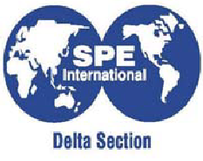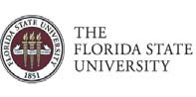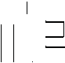Brief overview of student chapters
- Brief overview of upcoming SPE events
- Speed Mentoring:
  - All industry professionals in attendance will split up around the room into small groups. Students will rotate every 8 minutes (4 rotations total, 32 minutes). During the 8 minute mentoring, a question will be keyed up as a discussion opportunity. If discussion on that question falls short of 8 minutes, open discussion on the industry and topics of choice.
Sample Questions
- What are some of the most important work habits to adopt when coming into the energy industry?
- What are some of the challenges to expect when transitioning from school to a work lifestyle?
- What are the keys to success in the energy industry?
- What are employers today looking for as they hire graduates from the universities?

2017-2018 SPE Delta Sectio FFICERS and BOARD OF DIRECTOR
Section Chairperson Daniel Durey Shel
Section Past-Chairperson Angie Gobert BSEE
Program Chairperson - 1st vice chair Howard Duhon GATE
Membership Chairperson - 2nd vice chair Angie Gobert BSEE
Secretary Evan Graybill Chevron
Treasurer Jaime Villatoro BOEM
Vice Treasurer John Sanford TAM Internationa Young Professionals Chairperson Rebecca Collins BSEE
Student Chapter Liaison (LSU/Nicholls/FSU) Caitlin Papso Shel
Northshore Coordinator Matt Winters Chevron

Northshore Coordinator Ryan Smith Chevron
Communications / Internet Chairperson Forna Diphicyl BSEE
Continuing Education Chairperson Dan Alonso Cantium LLC
Scholarship / Career Guidance Ryan Smith Chevron Newsletter Contents & Advertising Nick Judice Hargrove Engineers + Constructors HSE / Section Director Michael Waguespack Waldemar S. Nelson
Section Director 2015/2017 Matt Wandstrat LLOG Exploration
Section Director 2015/2017 Phil Moses Consultant
Section Director 2015/2017 Lauren Woitha BOEM
Section Director 2016/2018 Henry Shurlds Onesource Prof Search
Section Director 2016/2018 Jan Catalano ORX
Section Director 2016/2018 Tony Richards Consultant
Section Director 2016/2018 Rivers Fike Shel
ONE VOICE Chairperson Jan Catalano ORX
Deepwater Symposium Liason (Aug 2017) Sue Barth Chevron
Sr. Advisor Allen Porter Consultant Golf Tournament Co-Chairperson Matt Wandstrat LLOG Exploration Golf Tournament Co-Chairperson Jerry Simms LLOG Exploration Active Past Chairs: Jan Catalano ORX
Charlie Mayne W&T Oﬀshore
Phil Moses Consultant
Tony Richards Consultant
Matt Wandstrat LLOG Exploration

In This Issue:
SPE April General Meeting & Luncheon - 1st Annual Student Chapter Review
Our Mission
To collect, disseminate, and exchange technical knowledge concerning the exploration, development and production of oil and gas resources and related technologies for the
public benefit; and to provide opportunities for professionals to enhance their technical and
professional competence.

Officers & Board of Directors 2
SPE DELTA SECTION
APRIL 2018
Mission Statement 2
SPE: On the Horizon 3
2017 Petroleum PE Exam 3
From the Chair 4
2018 Deepwater Technical Symposium: Save the Date! 5
March Membership Report 6
2018 SPE Delta Golf Tournament 7
2018 SPE Delta Golf Tournamet Photos 8
Family Fun Eat & Run 10
API Delta Chapter Sporting Clay Tourney 1
Bhopal: Deadliest Accident 12
AADE 2018 Scholarship Golf Tournament 16
Fueling Victory in World War II 20
Spotlight on Young Professionals 2
SPE's Mentoring Program 2
Dues Waiver / Out of Work? 2

SPE DELTA SECTION
APRIL 2018

SPE: ON THE HORIZON

APRIL
Apr. 17-18 SPE/IADC Managed Pressure Drilling and Underbalanced Operations Conference and Exhibition - New Orleans, LA
Apr. 20 SPE General Meeting and Luncheon 1st Annual Student Chapter Review
11:00 - 1:00 • Holiday Inn Downtown Superdome - New Orleans, LA
Apr. 29 PIPE Family Fun Eat & Run City Park • New Orleans, LA

MAY
TBA LSU PE Symposium
May 5 R. Scot Buell: Waterflood Design and Operational Best Practices May 11 AADE Scholarship Golf Tournament
Carter Plantation - Springfield, LA
May 15 Core Element's Hands-On STEM Day - Shrine on Airline • Metairie, LA • Gates open 9:30 am

JUNE
June 8 API Delta chapter Father-Son & Family Sporting Clay Tournament Covey Rise Lodge - Husser, LA

62% Pass 2017 Petroleum PE Exam  NCEES and the State Engineering Boards released their 2017 Professional Engineering Exam results. Nationwide, the Petroleum Engineering Exam recorded a 62% pass rate. The Petroleum first time takers passed at a 70% rate. The pass rates for a few other engineering disciplines were:  Chemical 64% Agricultural 71%  Civil 62% Fire Protection 55%  Electrical 58% Industrial 67%  Environmental 54% Metallurgical 65%  Mechanical 69% Mining 58%  Nuclear 71% Control Systems 73% The Petroleum pass rates in 2017 for a few states:  Alaska (2/2) 100% Louisiana (14/18) 78%  Pennsylvania (1/2) 50% Oklahoma (6/9) 67%  Colorado (13/16) 81% Texas (88/142) 62%  What are the requirements to take the Petroleum PE Exam? Today, Louisiana requires that you have:  - An engineering, math or science degree.  - Passed the Fundamentals, or FE Exam.  - At least four years of professional experience.  Interested? Contact the Louisiana State Engineering Board at  (225) 925-6291 for application forms. State web sites are also available at: www.ncees.org/licensure/licensing_boards. The Louisiana application deadline to take this years PE Exam is June 1, 2018. This year’s test will be given on Friday, October 26, 2018 |  | PROFESSIONAL REGISTRATION REVIEW COURSE FOR PETROLEUM ENGINEERING  COURSE DESCRIPTION: The Course covers most topics that are found on the State Board Petroleum Engineering Professional Examination.  WHO SHOULD ATTEND: Engineers who are planning on taking the PE Examination in Petroleum Engineering this fall.  NEW ORLEANS COURSE (8:00 AM - 5:00 PM)  Monday through Friday August 6 – 10, 2018  For More Information: 405-822-6761 E Mail: bingwines@cox.net  Web Site: winrockengineering.com  WINROCK ENGINEERING, INC.  P. O. BOX 42296 OKLAHOMA CITY, OK, 73123

SPE DELTA SECTION APRIL 2018

from THE CHAIR...

Hello everyone and welcome to April!
I want to take a moment and express my gratitude for the section board members. They continue to deliver high quality programs, activities, volunteer opportunities, community support, networking events, fundraising, college scholarships, and all with a dose of healthy fun. Their service is commendable, admirable and I am continually inspired by their eﬀorts.
Our upcoming events for April and May include the Family Fun Eat & Run, the annual Awards Banquet, and two general meetings/ uncheons. Be sure to review the newsletter for details and dates of these events.
The 2018 SPE Delta Section Golf Tournament at Carter Plantation was a huge success. Our sincerest thanks to the team sponsors, financial donators, hole sponsors, service providers
who gave of their time and resources to host tents and cook wagons on the course, student volunteers, and committee members who pulled this event together. The weather was perfect, and everyone I met had a great time. Profits from the tournament enabled the Delta Section to donate funds (3500 $/each) to seven diﬀerent engineering college departments. Thanks again for supporting this event and for participating in the fun.
The Family Fun Eat & Run is scheduled for April 29th. Once again this PIPE (Petroleum Industry Promoting Education) event benefits the three area Children’s Museums. This will be held at
City Park in New Orleans and will include a 5K Run/Walk and a Kids Dash Run/Walk. Please preview the advertisement in this newsletter for registration details.

I want to give a quick update on the Chili & Gumbo Cookoﬀ being planned between API Delta and SPE Delta. This event will now take place
in the Fall 2018 instead of late Spring or early Summer 2018. The committee members want to ensure this initial kick-oﬀ event is a success and therefore need more time for planning. Profits from this event are targeted for scholarships
for high school and college students pursuing degrees relevant to the oil and gas industry.
A reminder to all to keep your membership current and to encourage your colleagues who are not currently members to renew or join. It is your involvement and dues that enable the Delta Section to continue to deliver support to the local community and the industry. I also
encourage you to sign up and attend the monthly technical luncheons. Come out, network with your industry colleagues, have a good lunch and expand your knowledge.

Cheers,
Daniel A. Durey
Your 2017-2018 SPE Delta Section Chair

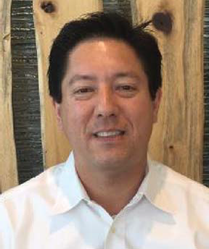
4

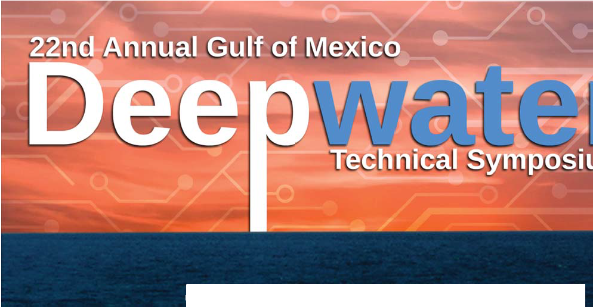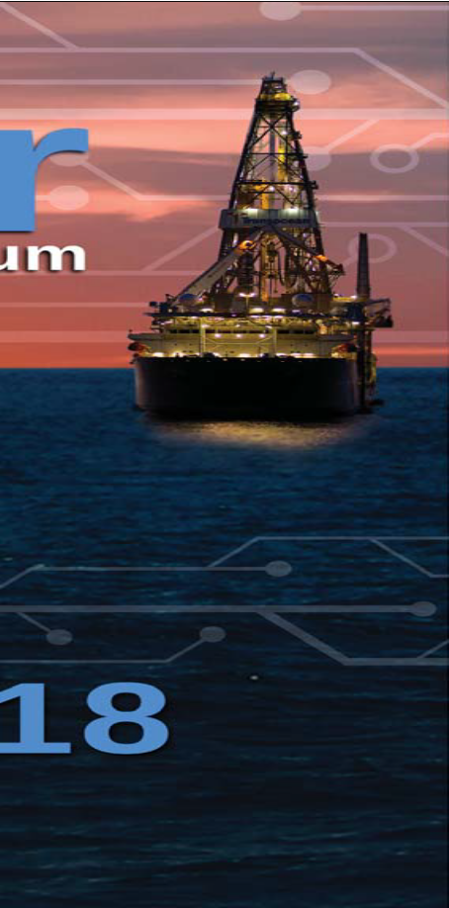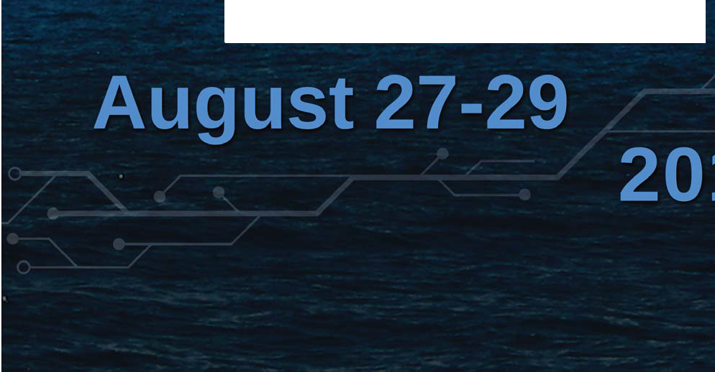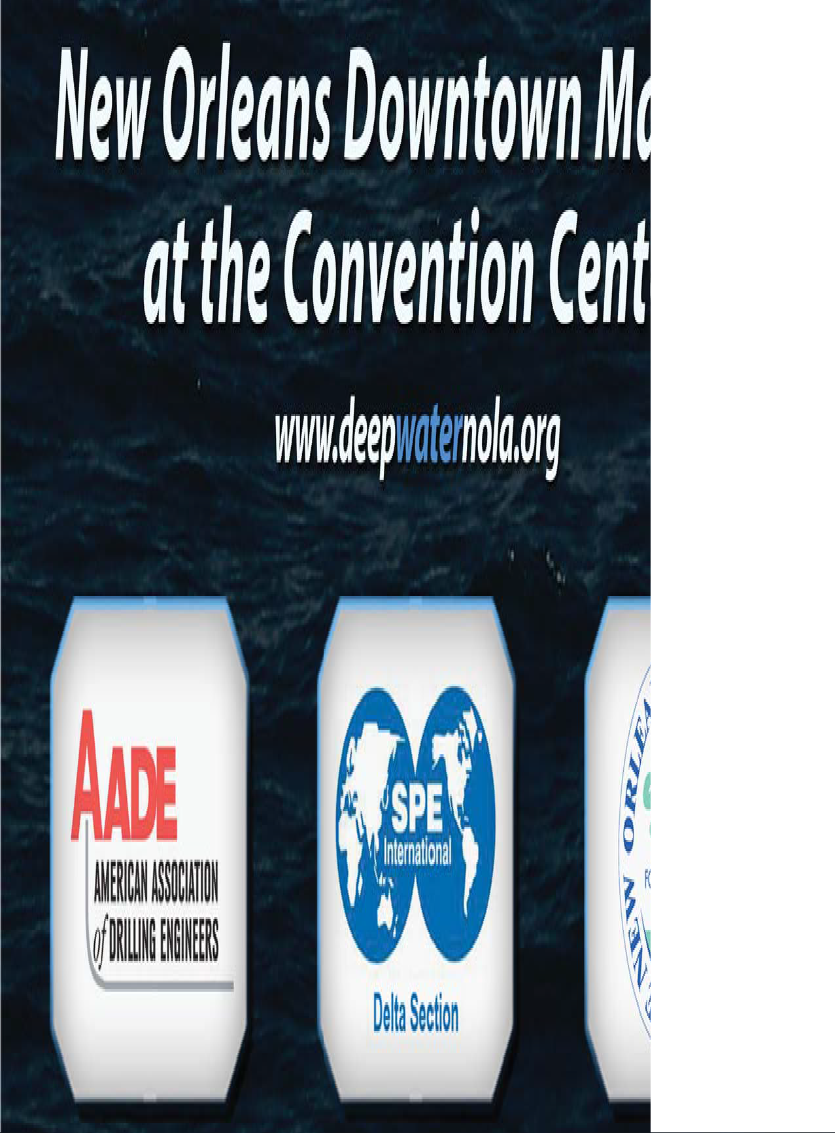SPE DELTA SECTION APRIL 2018

SAVE THE DATE!

5

SPE DELTA SECTION
APRIL 2018

SPE-Delta Membership Report
As of April 2018
Total Full Members
New Members Unpaid Members
Total Student Members
694
9
220
682

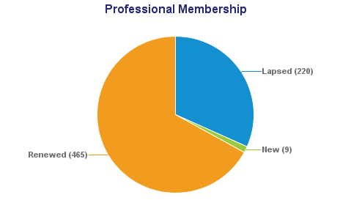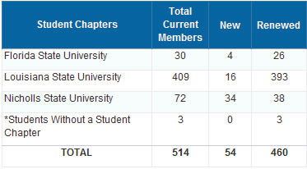

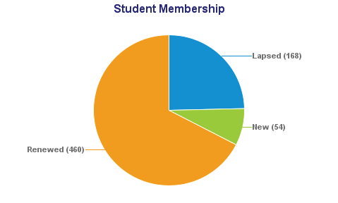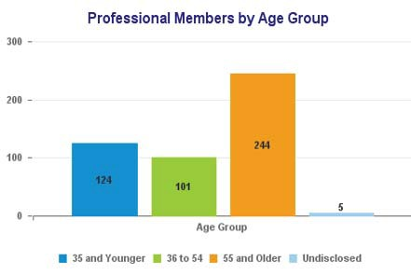

SPE DELTA SECTION
APRIL 2018

SPE Delta Section Golf Tournament Friday, March 9th

The annual SPE Delta Section Golf Tournament was held Friday March 9 at Carter Plantation. It was a great day for golf as well as supporting Engineering and Energy Education. The tournament was full with 32 teams and plenty for food and refreshments on the course.
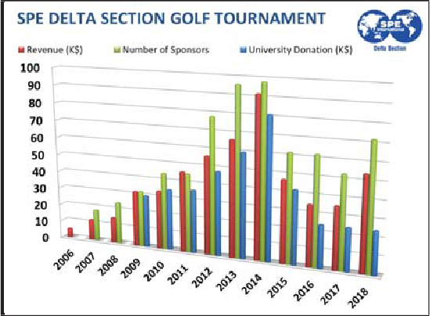
The committee started meeting back in January and set a goal to raise $50,000. I am proud to report that we surpassed that goal raising over $54,000. With that money we were able to support the seven universities each with a check of $3,500 as well as fully funding our application based scholarship program this year.

Special thanks to the committee for all their hard work and dedication to these goals:
Jerry Simms – Co Chair • Matt Wandstrat – Co Chair Ben Gary • Charlie Hebert • Lauren Polk
Louis Schneider • Lydia North • Torben Knudsen

Once again I would like to recognize our sponsors for making all of this possible
Champion Sponsors
Diversified Well Logging • Oasis Petroleum • TechnipFMC
Ace Sponsors
National Oilwell Varco • Workstrings International
Eagle Sponsors
B&B Rentals • Candy Fleet • Cox Operating • Exmar Oﬀshore • L&M Botruc • Nalco Champion Quality Rental Tools • RWO • Schlumberger • Birdie Sponsors • Bristow • CETCO
Crescent Drilling & Production • GeoMark Research • H&P • Impact Selector • LLOG Perma-Pipe Oil & Gas • Pinnacle Engineering • SeaTrax • Sooner Pipe • Tetra • Tubular Solutions
Par Sponsors
  - ro Industries • Concentric Pipe • Core Lab • Delmar • Enven Energy Ventures • Gibson Energy GLY-TECH Services • Guice Oﬀshore • Hunting Energy Services • Nacher • Newpark Drilling Fluids Oﬀshore Technical Compliance • Subsea 7 • Tristate Environmental • Weatherford
Playing Sponsors
Baker Hughes • Concentric Pipe • Core Labs • Cox Operating • Danos • Diversified Well Logging EnVen Energy Ventures • Enventure • TechnipFMC Ç GeoMark Research • H&P • Halliburton Innovex Downhole Solutions • Interwell • LLOG • MI SWACO Drilling Fluids • Nalco Champion Newpark Drilling Fluids • NNW Oil • NOV • OneSource • Rig Chem • RWO • Superior Performance Surbo Tubulars • TAM International • Tetra • Wellbore Fishing & Rental Tools
Cooking Sponsors
CETCO • Concentric Pipe and Tool Rentals • Diversified • EcoLab • Gly Tech • Guice Oﬀshore Hudson Services • Newpark Drilling Fluids • Oﬀshore Energy Services • Oﬀshore Technical Compliance
Quality Rental Tools • Wellbore Fishing & Rental Tools

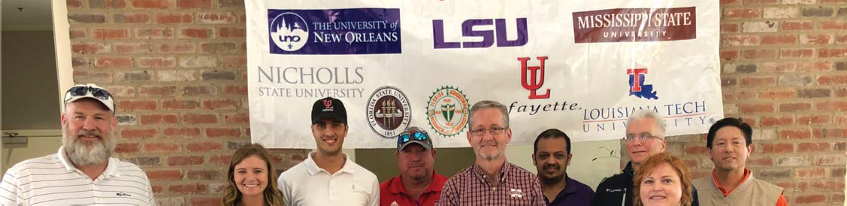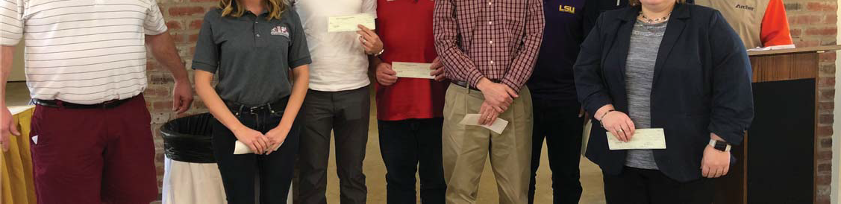

SPE DELTA 2018 GOLF TOURNAMENT
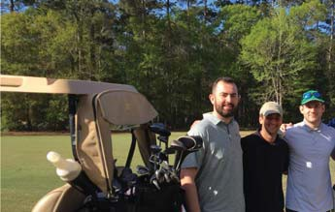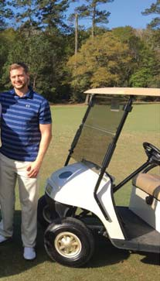

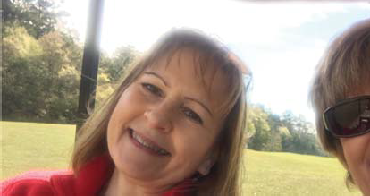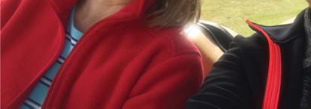

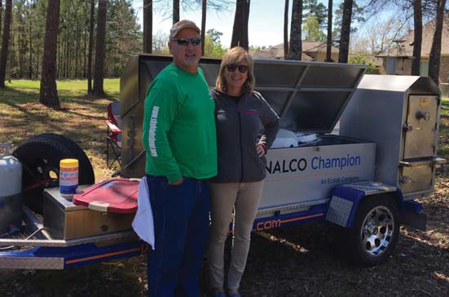

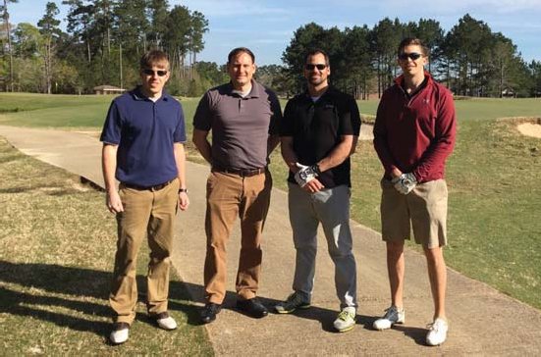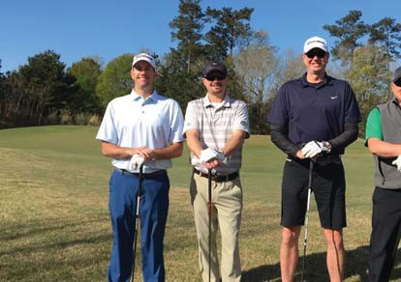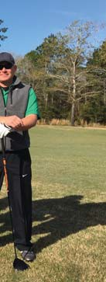

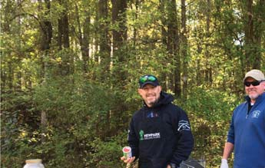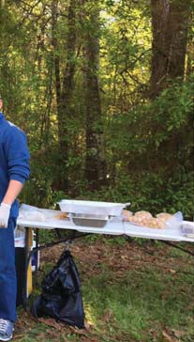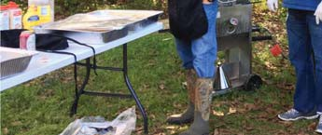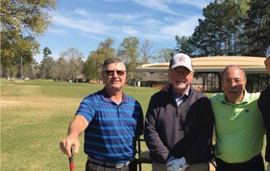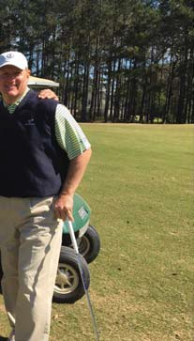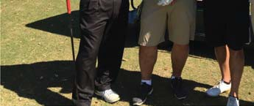
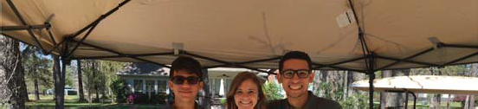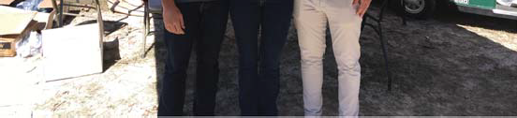

SPE DELTA SECTION
APRIL 2018

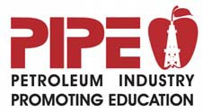
2018 Family Fun Eat & Run
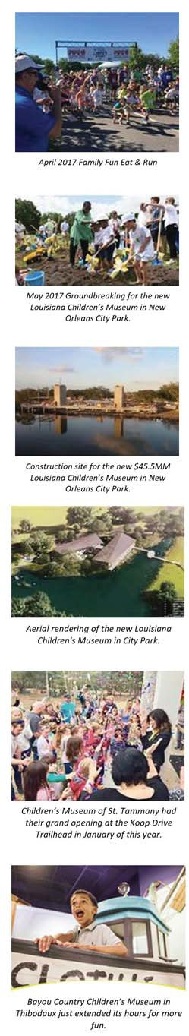
April 29, 2018 • City Park in New Orleans
The Petroleum Industry Promoting Education (PIPE), together with three area children's museums (New Orleans, St. Tammany and Thibodaux), is hosting the 3rd Annual Family Fun Eat & Run event on Sunday, April 29, 2018, in New
Orleans City Park. The event includes a 5k run/walk and a 1/2 mile run/walk for children. There will be food, drinks and other activities as well – this is an event for the whole family.
Proceeds from the event are distributed to the three children's museums for exhibits related to the energy industry. These exhibits will inspire children and improve perception of the energy industry for both locals and tourists who visit the museums. There is a great deal of development activity currently taking place at the museums, and a snapshot of this activity can be found on the left.
Also to the lest is a photo from last year's event, which was a complete success with 350 runners, 60 sponsors and 80 volunteers participating. Community partners like you provided essential support that ensured the event was a hugh success, and we were able to distribute almost $40,000 to the three children's
m .

We would like to ask for your support with the 2018 Family Fun Eat & Run on April 29, 2018, in City Park. You can support the event by:
    - Encouraging people in your company to attend. Register for the event at http://NOLArunning.com.
    - Have your company set up a food tent at the event.
    - Have your company sponsor the event. Sponsorship levels include: Title $1,000; Gold $500; and Silver $250. To sign up as a sponsor, go to http://connect.SPE.org/delta and look for the Family Fun Eat & Run event on April 29, 1028.

We know that times are extremely tough in our industry right now, and we are so proud of what our industry is doing to support its community. We strongly believe that energy-related exhibits will help provide education and insight that will inspire and improve perception of the energy industry.
Thank you again for your donation and continued support. Sincerely,
Rick Fowler, Event Chair
PIPE Chairman, LLOG Exploration Oﬀshore
Leslie Hellmers, Event Chair
Hornbeck Oﬀshore Services

March, 2018

SPE DELTA SECTION
APRIL 2018
2018 Delta Chapter Chairman:
Ben Gary

2018 Tournament Committee: CHAIRMAN
Barney Paternostro
LLOG

COMMITTEE

Jake Carpenter
Halliburton

Bernadette Alaniz
RCS

Joe Bernard
ProͲT

Earl Devall
Cetco

Blake Bergeron
Supreme Services

Steve Walsh
Sea Trepid

Ed Stegall
Tetra

Kyle Lafont
B&B Rentals

Ryan Adams
Helis Oil & Gas

Daniel Durey Shell

Fellow Petroleum Industry Sporting Clay Enthusiast,

The API Delta Chapter of New Orleans is proud to announce that we are holding our 14th annual FatherͲSon & Family Sporting Clay Tournament on Friday, June 8, 2018, at the Covey Rise Lodge located in Husser, LA. The annual API Sporting Clay Tournament promotes friendly competition, and sporting clay skills to our oil field industry participants and their families.

This event offers a wide range of competition for both the family and the individual. In the interest of safety, participants must be 15 years or older. The tournament opens at 3:00 on Thursday the 7th with registration and practice course until 6:00 PM. On Friday the shooting
time starts promptly at 9:00 AM. Shooters should be ready for safety meeting at 8:30. The 5Ͳ Stand, Flurry and Long Bird will close at 1:30 p.m. on Friday.

The main event will present a multiͲstand, 100 clays course. Awards will go to high individual and team winners based on Lewis Class Scoring. Additionally, top scores in 5Ͳ Stand, TwoͲ Person Flurry and Long Bird will receive awards.

Proceeds from the tournament are used to support API Delta Chapter activities and programs, awards, scholarships and the ongoing promotion of the petroleum industry in local schools and universities. Through your generosity and participation API Delta Chapter has been able to provide ongoing support and funding for programs such as the following:

x Scholarships ($10,000 in 2017) for local high school graduates and college students supporting industry related degrees.
x Contribute $15,000 to the Louisiana Children’s Museum and Northshore Children’s Museum where API Delta sponsors the Energy Exhibit.
x Awarded over $6,000 to local teachers with the Teacher of the Year Awards
x Mini Grants program to teachers, designed to help fund the purchase of supplies and teaching equipment.
x The Energy projects division of the Greater New Orleans Science & Engineering Fair was started by our Chapter. Monetary awards recognize students with winning science projects in the energy category, along with their teachers and
schools.
x The annual API Meritorious Service Award which recognizes local individuals for their outstanding service and leadership in the oil and gas industry and community service.

Your support of the tournament will ensure its success and help APIͲDelta Chapter continue its efforts to promote the petroleum industry in the region.

You can go to our website www.apiͲdelta.org for tournament information and forms.

We look forward to seeing you at this year’s APIͲDelta Chapter Golf Tournament and thank you in advance for your generous support.

Sincerely,

Barney Paternostro
LLOG Exploration Co., LLC

ROOT CAUSE ANALYSIS OF THE DEADLIEST ACCIDENT IN HUMAN HISTORY
By: Howard Duhon, P.E.
This article has been updated from an article that first appeared in Oil and Gas Magazine in April, 2014.

SPE DELTA SECTION
APRIL 2018
In the 11th century CE, Raja Bogh of Dhar founded a city on the shores of a beautiful lake in central India.
Today that city is a bustling metropolis with 1.8 million people. The city and surrounding area is home to a large wildlife refuge, a museum of Indian tribal life, a collection of historical palaces and temples and some stone-age cave paintings.
Almost anywhere else in the world this city would be a major tourist attraction, but in history-rich India there is stiﬀ competition for tourist attention. Bhopal is not well-known as a tourist destination. It is ‘on the map’ for something else; it is the site of the deadliest industrial accident in human history.
The Accident
In the early morning hours of Dec 3, 1984, a large toxic gas release from a Union Carbide India Limited (UCIL) pesticide plant swept over a large, densely populated area south of the plant.
About 500,000 people downwind were exposed to the gas cloud. Thousands of people died in the immediate aftermath. We don’t know how many died. A commonly accepted number is 2000 (2007, D’Silva), but it may be
as high as 8000 (2004, Amnesty International). Tens of thousands were severely injured. Thousands of those died prematurely of their injuries in the months and years following the release.
The cloud wafted over the railway station 2 km away where many people waiting for and arriving on trains died. One of the heroes of the day was the dispatcher who died warning oﬀ approaching trains.
Thirty years on, numerous international organizations are still at work in Bhopal studying the aftermath and assisting individuals still suﬀering from the accident.
Personal Connection
I was an employee of Union Carbide Corporation (UCC), the US parent company of UCIL, at the time of the accident. Like all UCC employees of the time, I know exactly where I was when I first heard the news.
While traveling in India recently I took the opportunity to travel to Bhopal to see the site of the accident.
The plant has been idle for thirty years, rusting away, overgrown with trees and shrubs. Figure 1 is a picture of the tank where the reaction occurred – abandoned to the weeds after the investigation was concluded. Many have clamored through the years to have the site demolished and cleaned up. Others have petitioned that it be maintained as a UNESCO World Heritage Site.
What is striking about the neighborhood around the plant is that the accident is still ‘alive’ there.

Billboards and graﬃti demand restitution. Hospitals and rehabilitation centers continue to treat the injured. Thousands still seek medical attention for continuing medical problems include especially lung damage, but also immune system impairment, neurological damage, cancers, gynaecological disorders, mental health issues (2004, Amnesty International). And the accident has caused significant social and economic problems. An already poor area was made much poorer. Many families lost their sole breadwinner. Others lost their employment. Young women exposed to the gas cloud carry a social stigma and have great diﬃculty finding husbands.
In the years since, I have frequently been struck by how little most people know about this accident.
As the thirtieth anniversary of the event approaches, I think that it is important to remember those killed and injured in the accident, and to further resolve ourselves
to learn from this accident so that nothing like it will ever happen again.

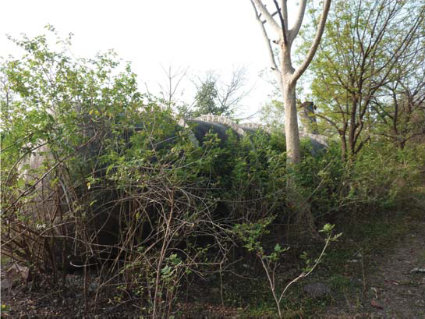
Figure 1 – Tank E-610

The Political, Legal, Economic and Social Environment
Trevor Kletz has argued that there is no such thing as a root cause – only a point at which we stop asking questions. In this case I think that it is appropriate to
take the inquiry back to the days of the Raj, the colonial occupation of India, because the residue of colonialism impacted the psyche the people and the political and legal systems of the country in ways that contributed to the tragedy.
Figure 2 illustrates the environment in place at the time of the accident.

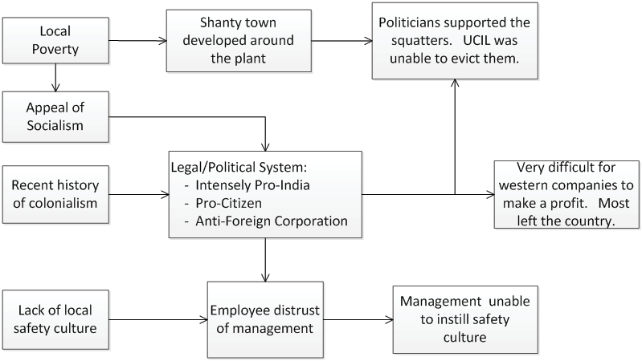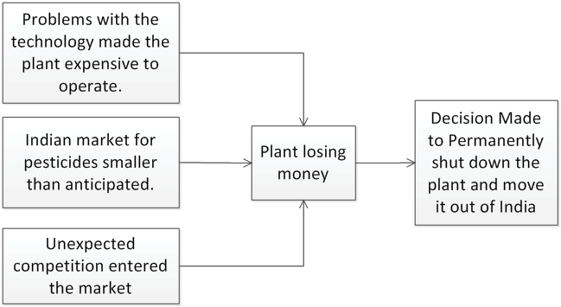

Figure 2: Social, Legal, Political Culture
Starting from the left we have four important drivers:
- The very recent history of colonialism – the domination of India by a foreign power
- The general poverty of the country and abject poverty of many people near the plant
- The appeal of socialism in India at that point in history
- Lack of a safety culture.
In the second column of Figure 2 we see some impacts of these drivers.
- There developed a legal system that was unashamedly pro-India, pro-citizen and anti-foreign corporation.
- A shanty town developed quickly in undeveloped land around the plant. That land was supposed to be a buﬀer area. Local politicians supported the squatters and rebuﬀed UCILs attempts to evict the squatters.
- Employee’s mistrust of management made it diﬃcult to install a safety culture appropriate to the risks inherent in the plant. Indeed it was virtually impossible to even investigate incidences and near
misses because they were covered up by the workers.
Another important factor in the accident is that the plant was not making money. There were several reasons including:
  - Sales of pesticides were much lower than predicted due to economic hardships in India.
  - Unexpected competition meant that even that small market was shared.
  - Manufacturing costs were high due to problems with the technology.
UCIL had decided to permanently shut down the plant and ship it out of India. The plant was in its last production run at the time of the accident, working oﬀ the last batch of Methyl Isocyanate (MIC). Many or all of the employees would have been laid oﬀ within days.
It is against this legal, political, economic and social backdrop that the final events and decisions leading to the tragedy unfolded.
Figure 3 - Economic Situation

Plant Description
Figure 4 below illustrates the important features of the pesticide production facilities. Methyl Isocyanate (MIC) was produced onsite (MIC Production Plant) and consumed onsite as a raw material in the Pesticide Plant.
The plant design (partially batch) required some MIC storage. MIC storage was supposed to be kept to a minimum. A Caustic Scrubber was provided to neutralize MIC vented from the storage tanks.
A flare was provided to burn MIC vented from the storage tanks.
A refrigeration system was provided to keep the stored MIC cold. Keeping the MIC cold decreases the reaction rate of MIC with water and other contaminants.

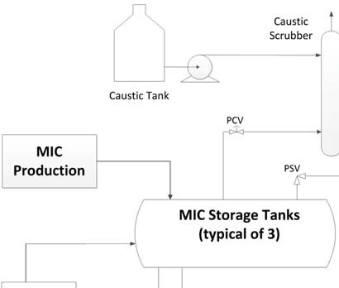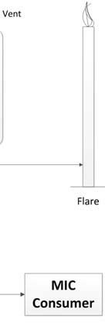
Figure 4 – Plant Process Schematic
The Initiating Event – Sabotage
Accidents are usually consider to begin with one triggering (initiating) event. The initiating event for Bhopal was the introduction of a large amount of water into the tank (about 200 gallons). MIC is a stable compound, but it is very reactive with water.
There is some controversy over how the water got there. One story is that operators in another part of the plant were water-washing a filter and did not properly

isolate the filter system, allowing water to reach the MIC tank. This story does not pass technical muster; simple pressure drop calculations show the scenario to be unlikely if not impossible. But this scenario is still argued by some who have vested legal and political interests in it being true.
The true cause is likely to have been sabotage – a disgruntled worker intentionally injected water into the tank, presumable to ruin the batch of MIC.
The reaction of MIC with water is exothermic (gives oﬀ heat). As the reaction progressed the tank temperature and pressure increased, slowly at first, but then at an accelerating rate until the venting began.
Safeguards Bypassed or Broken
Significant safeguards were in place to prevent an MIC release or at least to minimize its impact, but all were ineﬀective that night.
No Means of Adding Water to the Tank
t is common in industrial facilities to have valves and drains on piping systems to make it easy to vent and drain systems and to inject water, steam, nitrogen, air, etc. for purging or cleaning the system. The designers of the Bhopal facility were aware that accidental injection of water could be catastrophic. Hence the system as nstalled had no drains or vents.
Safeguard Defeated: Injection of water could not have been a simple human error. It appears that the saboteur remove a pressure gauge and installed a hose connection in its place.
The other safeguards were probably adequate for handling any typical initiating event. They may not have been adequate to handle a case of sabotage, since it is unlikely that the designers would have considered this a credible event. But we will never know that, because all of the other safeguards were bypassed.
Minimizing MIC Stored Volume
The simplest of planned safeguards was to minimize the quantity of MIC stored. The less MIC that is stored, the less that can be vented.
As noted above there were three storage tanks. By procedure, two should have been empty and the third should have had less than 50% level (Figure 5). On the day of the accident, the levels in tanks E-610 and E-611 were about 70%.
Figure 5 – What the Tank Levels Should Have Been
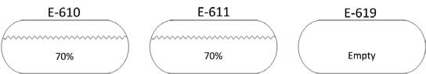
Figure 6 – What the Tank Levels Were
Operating with less MIC inventory would have decreased the volume of MIC vented and may also have given the operators the options to add diluent to slow the reaction and the option to move some MIC into a vacant tank.
During the event the operators apparently became aware that water had been injected into the tank and they transferred about 500 gallons from the bottom of tank
E-610 into to the empty tank, E-619. Unfortunately they were flying blind unaware how much water was in the tank and so they apparently did not transfer enough to have a significant impact. And there apparently were no procedures to guide this eﬀort.
Refrigeration System Oﬀ
The rate of an exothermic reaction is decreased by decreasing the temperature. A refrigeration system was provided to keep the MIC at about 30 oF.
Safeguard Defeated: The refrigeration system was out of service and Tank E-610 was operating at about 70 oF. This likely resulted in a reaction rate orders of magnitude higher than it would have been.
It is commonly believed that the cause of this was the desire to avoid the cost of operating the refrigeration system and the cost of maintenance. While there may be some validity to those arguments, the refrigeration system was actually shutdown for safety reasons. MIC
was pumped through the refrigeration system. Seal leaks in the pumps were a significant safety issue.
Out of Caustic?
The vented MIC escaped through the Vent Gas Scrubber (Caustic Scrubber).
Safeguard Defeated: There is much conflicting information about this. The investigations found the caustic tank empty. There was speculation that this was a cost cutting move.
I suspect that the caustic scrubber was sued early in the incident. But the flowrate of vented gas was so much higher than the scrubber was designed to handle, the caustic was blown overhead with minimal eﬀect on the gas.
Flare Out of Service
The bulk of the gas should have gone to flare where it would have been burned orat least vented higher up promoting better dispersion.
THE FLARE WAS OUT OF SERVICE! A section of pipe
n the flare header was corroded and the flare was taken out of service. A decision was made to perform the final pesticide production run without a flare.
Shanty Town in the Plant Buﬀer Area
India is a crowded place with inadequate public transportation. The UCIL plant was a major employer. It was natural that people would want to live near the plant. The poorest of the poor set up a shanty town along the plant fence, many literally using the plant’s concrete fence

as one wall of their house. UCIL tried multiple times to have the shanty town removed, but was unsuccessful; the shanty town residence were voters and local politicians supported them .
Though people as far as 2 km away from the plant were killed, many of the dead and severely injured were squatters living ‘illegally’ immediately along the plant fence.
neﬀective Emergency Response
No on-duty UCIL employees were killed in the event.
This is largely due to relevant knowledge – the plant operators knew what was happening and which direction the wind was blowing, so they knew which way to evacuate.
An eﬀective emergency response would undoubtedly have saved many in the community. UCIL issued no alarm to the community and provided no information to civil authorities until about 2 hours after the initial release.
neﬀective Treatment of the Injured
A final safeguard would have been eﬀective treatment of the injured. In the immediate aftermath the doctors didn’t know the cause of the incident and so didn’t know how to treat the injured.
Perfect Storm
In all or most major accidents we see this pattern of multiple things going wrong. The list of things that went wrong at Bhopal is striking including:
- The plant was losing a great deal of money due in part to mismanagement and in large part to a
political and legal system that made it very diﬃcult for western companies to make a profit and even more diﬃcult to expatriate out of India any profit that they did manage to make. Most western firms left the country in this period (including IBM and Coca Cola).
- A social system that dismissed safety culture and created extreme tension between management and workers (to the extreme that one disgruntled worker was willing to intentionally ruin a batch of MIC),
- The fact that the plant was closing permanently which, no doubt, significantly aﬀected operator morale and contributed to the lack of maintenance and the bypassing of safety systems,
- Adverse meteorological conditions –stable conditions with low wind speed kept the gas cloud intact for an extended period of time and moved it slowly over a large section of the city.
- The complete failure or lack of an emergency response program.
- Ineﬀective treatment of the injured.
It is unlikely that there will ever be another industrial event as deadly as Bhopal, it really is a ‘perfect storm’ event.
What We’ve Learned
Bhopal has had significant impact on safety culture the world over in multiple industries. HAZOPs, dispersion studies, management of change programs are now commonplace.
Plants around the world immediately moved to limit the storage and shipping of toxic materials. It is unlikely that anyone will ever again store 15000 gallons of a substance as toxic as MIC.
What We Haven’t Learned
There is a large irony here. We have learned to design safer plants, but the plant design played only a small role in the accident. Bhopal was caused by failure to operate the plant as the designers intended:
- in bypassing safeguarding systems in particular
- and in violating Standard Operating Procedures (SOPs) in general.
UCC recognized the failure to follow SOPs as a root cause and launched a corporate wide program to update SOPs and instill a culture of using them eﬀectively. In the years since, the airline industry has learned to make SOP following a priority. This has resulted in remarkable improvements in the safety of air travel.
It is a lesson that the Oil and Gas Industry has yet to earn.

Sources
There is so much written about the Bhopal tragedy and so much of it is contradictory, that it is diﬃcult to form opinions on many issues. I’ve found these two documents to be particularly useful.
2007, Themistocles D’Silva, Black Box of Bhopal, A Closer Look at the World’s Deadliest Industrial Accident Traﬀord, Victoria, BC, Canada
D’Silva was an engineer working for UCC in the
Agricultural Products Division at the time of the accident. He participated in the accident investigation. He wrote this book after he retired. I consider it the definitive book on the accident. The majority of the information in this article can be found in D’Silva’s book.
2004, Amnesty International, Clouds of Injustice, Bhopal Disaster 20 years On, Amnesty International Publications, London
If D’Silva has a bias it is in favor of UCC, his long-term employer. Clouds of Injustice is the story from a diﬀerent viewpoint, clearly biased in favor of the impacted locals. This document provides an extensive coverage of lingering health problems in the aﬀected population.

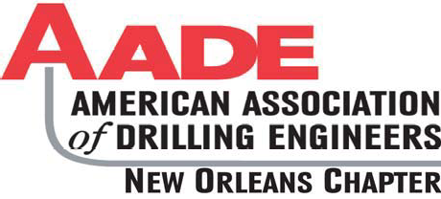
Scholarship Golf Tournament
Attn: Scott McDonald
2400 Veterans Memorial Blvd, Suite 110
Kenner, LA 70062

AADE BOARD

Odon Simoneaux Ͳ President
Wild Well

Rivers FikeͲ 1st VP
Shell

Emile GoodwinͲ 2nd VP
Chevron

Karen Armand Ͳ Treasurer
AADE

Christine Chatelain Ͳ Secretary
Shell

GOLF COMMITTEE

Scott McDonald
Crescent Drilling & Production
Christine Chatelain Shell

Bernadette Alaniz AADE

Rose Bourgeois
AADE
Karen Armand
AADE
Lauren Polk
RigͲChem
Leah Bennett
UV Logistics
2018 AADE GOLF TOURNAMENT
5/11/18 - Carter Plantation - Springfield, LA

We are looking forward to another year at the Carter Plantation for our annual Scholarship Golf Tournament on Friday, May 11, 2018.

The success of our Golf Tournament is fundamental to the AADE's ability to provide scholarships and various university projects in our communities.
Without the continued support of our Operators and Service Providers, the AADE would be unable to support our local universities and students. We will continue with the reduced rate of $175 per golfer, as we understand slowdowns in our industry have affected everyone. We appreciate your continued support throughout tough times in the industry and request that you continue to support our effort to maintain our mission of education and support for the Oil & Gas industry.
Sponsorships include: corporate, team, hole, and food or beverages on
*Please see the list below to contact the appropriate person for your sponsorship.

Registration forms can be mailed or e-mailed to Scott McDonald at the addresses listed above.
Don't have a Foursome? Don't worry! We welcome singles and will match
players together to form a great team.

SPONSORSHIPS & DOOR PRIZES
Scott McDonald - Crescent Drilling & Production Inc. - 504/467-5100 Scott.mcdonald@crescentdrilling.com

HOLE PRIZES/SPONSORSHIPS
Christine Chatelain - Shell - 985-652-7560 christine.chatelain2@shell.com

FOOD
Leah Bennett - UV Logistics - 504/919-1810 leah.bennett@uvlogistics.com

GENERAL INFORMATION
Bernadette Alaniz - AADE - 504/453-6222

Karen Armand - AADE karenarmand32@gmail.com
Rose Bourgeois - AADE - 504/ 452-5896 bourrosm@outlook.com.

You don't want to miss this event! We look forward to seeing you there!

www.AADE.org/chapters/New Orleans

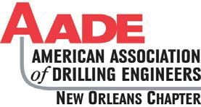
2018 AADE Scholarship Golf Tournament

FRIDAY May 11, 2018
Carter Plantation Golf Club

Sponsorship Levels

Gold Sponsorship

$1,500 – Top Billing on Sponsorship Banner

Silver Sponsorship
$750 – Sponsorship Banner

Bronze Sponsorship
$400 – Sponsorship Banner

Hole Sponsorship & Cooking Teams
$200 – Hole Sign

Profits will support the AADE New Orleans Chapter Scholarship Fund for the following universities
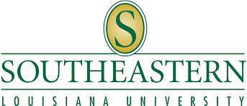

If you have any questions please contact:

Scott McDonald 504/ 467Ͳ5100 scott.mcdonald@crescentdrilling.com

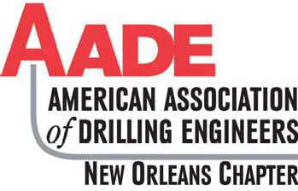
SCHOLARSHIP GOLF

Tournament May 11, 2018
Carter Plantation - Springfield, LA

DRESS CODE: No Denim Allowed - Shirts must have Collars
FORMAT - 4-MAN SCRAMBLE
$175.00 Per Player Fee - Includes Cart, Green Fees, 1 Mulligan per golfer, Food & Drinks on Course
SPACE LIMITED: ALL ENTRIES "FIRST-COME" - "FIRST-SERVED"
AADE is a non-profit organization under Sec. 501(c) (6) of the Internal Revenue Code. Taxpayer ID #72-1147333

TEAM CONTACT
NAME | $ 175.00 |  | NAME |  | $ 175.00
COMPANY |  |  | COMPANY
EMAIL |  |  | EMAIL
ADDRESS |  |  | ADDRESS
CITY ST ZIP |  |  | CITY ST ZIP
PHONE |  |  | PHONE
NAME | $ 175.00 |  | NAME |  | $ 175.00
COMPANY |  |  | COMPANY
EMAIL |  |  | EMAIL
ADDRESS |  |  | ADDRESS
CITY ST ZIP |  |  | CITY ST ZIP
PHONE |  |  | PHONE
Tee Time 7:45 a.m. (Shotgun Start) |  |  |  | TOTAL $

NOTE: Confirmation will be sent to Sponsor Contact via Email Only. Print Email Address Clearly
Payment Method: VISA MasterCard AmEx Check Cash IOU See Credit Card Authorization Form for Credit Card Payments
* Trade Entry fee for: 2016 or newer Truck Debt Free 1000 HP rig 106 bbls WTI Crude Oil
Trades are at the discretion of the golf chairman
MAIL REGISTRATION FORM AND PAYMENT TO:
Scott McDonald / Crescent Drilling & Production, Inc. 2400 Veterans Memorial Blvd. Suite 110 Kenner, LA. 70062
AADE & GENERAL COMMITTEE  President - Odon Simoneaux  Wild Well  1st VP- Rivers Fike  Shell  2nd VP- Emile Goodwin  Chevron  Treasurer - Karen Armand  AADE  Secretary – Christine Chatelain  Shell | CHAIRMAN
 | SPONSORSHIPS AND DOOR PRIZES
 | Scott McDonald | RAFFLE BOARDS
 | Crescent Drilling & Production, Inc. | Lauren Polk - Rig-Chem
 | 504/467-5100 | 985/226-0940
 | scott.mcdonald@crescentdrilling.com | Lpolk@rigchem.com
 | REGISTRATION
 | Bernadette Alaniz | FOOD COMMITTEE
 | Christine Chatelain | Leah Bennett - UV Logistics
 | Christine.Chatelain2@shell.com | 504/919-1810
 | Rose Bourgeois | leah.bennett@uvlogistics.com
 | bourrosm@outlook.com.
 | Karen Armand
 | karenarmand32@gmail.com

Credit Card Authorization Form 2018 AADE Scholarship Golf Tournament
AADE is a non-profit organization under Sec. 501(c) (6) of the Internal Revenue Code.
Taxpayer ID #72-1147333

Name as it appears on card:

Company Name:

Credit Card Type: (Visa/MC/AMEX)

Credit Card number:

Expiration Date: CVV Code:

Credit Card Billing Address (Include zip code):

Phone Number:

Charge Amount:

Signature:

E-mail:
A receipt will be emailed to the individual.

ͲͲͲͲͲͲͲͲͲͲͲͲͲͲͲͲͲͲͲͲͲͲͲͲͲͲͲͲͲͲͲͲͲͲͲͲͲͲͲͲͲͲͲͲͲͲͲͲͲͲͲͲͲͲͲͲͲͲͲͲͲͲͲͲͲͲͲͲͲͲͲͲͲͲͲͲͲͲͲͲͲͲͲͲͲͲͲͲͲͲͲͲͲͲ
Paying By Check:
Make Check Payable to: AADE New Orleans Chapter

Mail to: Scott McDonald
Crescent Drilling & Production, Inc. 2400 Veterans Memorial Blvd.
Suite 110
Kenner, LA 70062

The National WWII Museum in New Orleans is a remarkable place. It contains snippets of oil’s role in winning the war, but not much of that story.
Armies, navies, air forces consume vast quantities of resources. Oil - lots of it - was required to make the victory possible.
SPE Delta is launching a study to develop the story of fuel, oil in particular, in winning WWII.
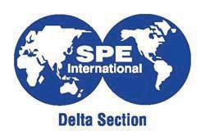We are looking for volunteers willing to dive-in and research this piece of
If you would like to be involved, please contact Howard Duhon at hduhon@gateinc.com.
20
history to tell the story of how much was needed, where it came from, KRZ LW ZDV IRXQG, SURGXFHG, UHÀQHG,
conserved, transported, and fought over, how it affected military strategy and about the people who made it all happen.
We hope that eventually the story we develop will be presented in the National WWII Museum.
This is likely to be a multi-year effort. Our
ÀUVW JRDO ZLOO OLNHO\ WR EH GHYHORSPHQW
of a short documentary video.

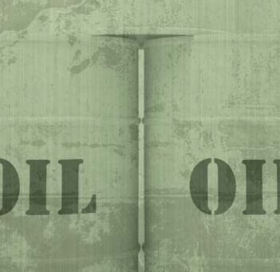
SPE DELTA SECTION
APRIL 2018

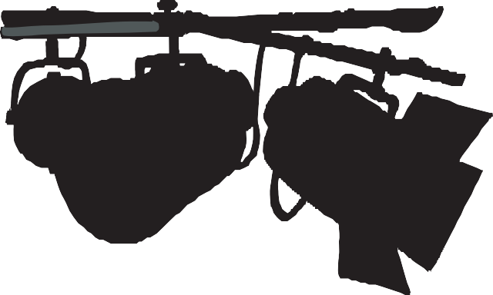
SPE DELTA SECTION
APRIL 2018

Spotlight on Young Professionals
Do you know a young professional who deserves to be put in the Spotlight? If so, suggest them (or yourself) to be featured in the “Spotlight on Young Professionals.” Help us identify worthy young professionals by submitting your story today for a chance to be featured in The Way Ahead™.

Learn more at http://www.spe.org/members/yps.php
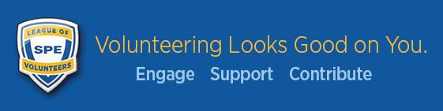

Become a Mentor through SPE’s eMentoring Program
eMentoring gives SPE members a way to contribute to the E&P industry by sharing industry insights and practical career advice with young professionals, or by helping university students with academic and career direction. Young professionals also have the unique opportunity to serve as mentors to students.
Join the program today by going to http://www.spe.org/ementoring/

Dues Waiver
SPE offers a dues waiver for renewing members who have lost their jobs due to the industry downturn and other circumstances. To qualify, submit a written request by either postal mail or email to service@spe.org.

Out of Work?
Check out the Members in Transition Toolkit at http://www.spe.org/members/transition/. Learn how to optimize your job search, develop your network, enhance your skills, and thrive in a downturn.
21

